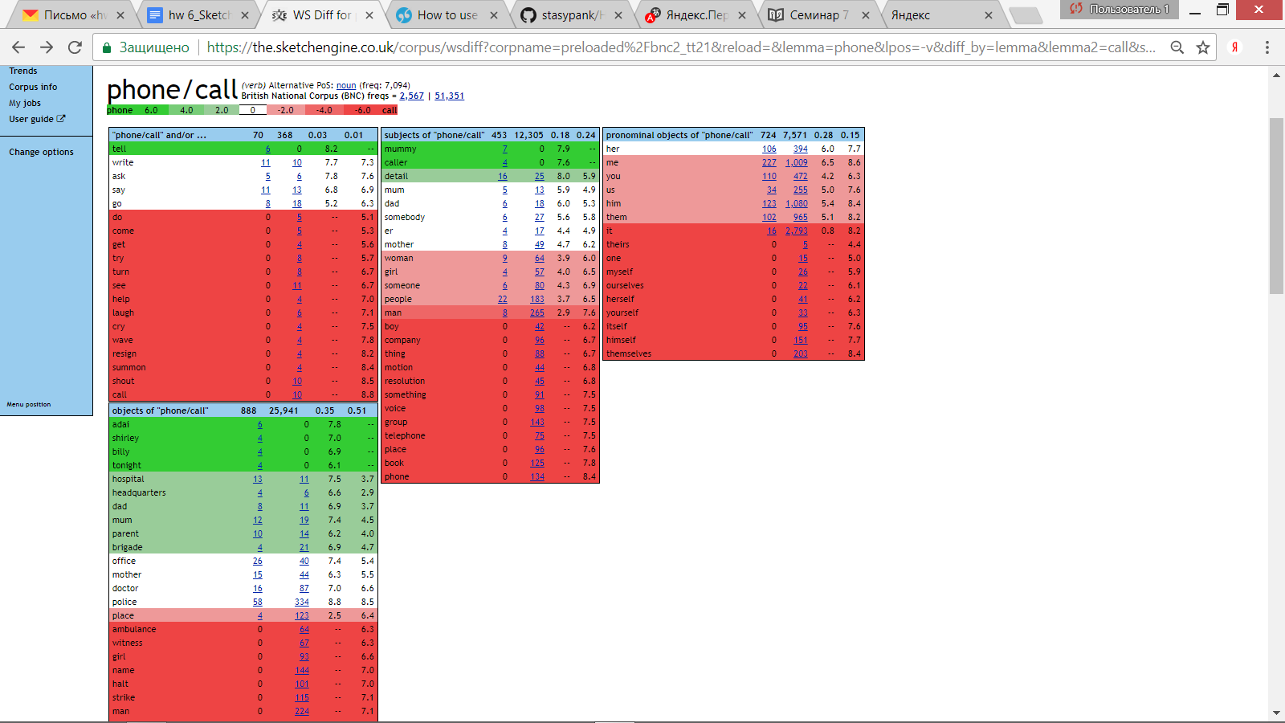

1. Оба глагола могут употребляться с дополнением ***mother*** :

«Written books and periodicals pointed out. 'You've just told me that the girls **phone** their ***mother***every night. So if you had a word»

«Written books and periodicals he's going to die. Give him another year and I'll **call** my ***mother***every week. Just another year.»

1. C дополнением ***tonight*** может употребляться только глагол **call**:

«Written books and periodicals out at the moment but he'll be in later and he'll **phone** either ***tonight***or in the morning»

1. C дополнением ***name*** может употребляться только глагол **phone**:

«Written books and periodicals not there. The kitchen was dark. Patrick did not **call** his ***name***. He went back to the hall and listened.»